ABET
ADS Assignment

for the

Computer Science

Program
at

University of Texas at Arlington

Arlington, TX

Jeremiah Richard

09 August 2023

Dataflow Diagram
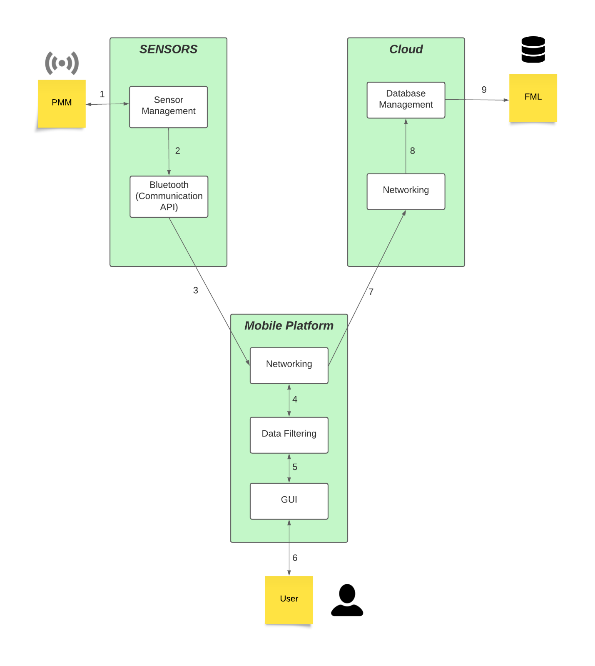

Connection Table
ID | Description | Inputs | Outputs
1 | Send sensory data; Send program commands | Application regulatory communication with PMM’s sensors | Raw Sensory data
2 | Send data to be packaged for network travel | N/A | Code-structured Sensory data
3 | Bluetooth sends data to mobile application | N/A | Packaged Sensory data
4 | Send data to be filtered | Filtered Data | Unfiltered sensor data; filtered data
5 | Send data to be displayed | Data to be filtered (by user commands) | Filtered data
6 | Show Sensor Data | User Commands | UI formatted - Sensor Data
7 | Send filtered data | N/A | Packaged filtered data
8 | Save Data in database | N/A | Filtered data
9 | Data displayed on FML | N/A | Filtered data

The development of an app such as this could have a considerable impact on how many use their electric wheelchairs, but it would provide ample data for the improvement of such wheelchairs. In health, it would encourage many to gauge their usage of said electric wheelchair for health benefits if a said chair was desperately needed or not as needed for rehabilitation purposes. Socially, although many may desire more information and awareness, others may see such access as a danger to their personal information, especially with the FMS system applied that could monitor statistics in real-time. Ultimately, having such data would be invaluable, but easily exploitable if abused with no encryption from FMS or the cloud layer.
Still, in exploring development and health, this data could be used to improve the battery life of electric wheelchairs while remaining cost-effective, diagnosing errors and failures with certain components of the wheelchair, sending an emergency call when fatal failures are meet with statistics of the geolocation or just to identify personnel and licenses as evidence to help in various legal cases. Additionally, this data, if extended in capability could be modified with specialized sensors to identify likely health problems and aid medical staff in the recovery of patients or just quality of life for those in need of said chairs long-term. UI to even be considered for this can manage time usage on the electric chair and speed to protect certain patients and certain configurations could use levers or robotic attachments to help with use if there are disabilities in patients’ arms or legs.
However, with such a benefit, the greatest danger is the mass of data that could be collected and stored over the FMS with the implantation of the mobile app. It would allow many to stalk those in said chairs or collect personal data to be illegally sold. Particularly, a sensor used to note geographical data could be dangerous if said information came to malicious parties. Besides such an ethical safety dilemma there would be stark health and quality of life aid.

